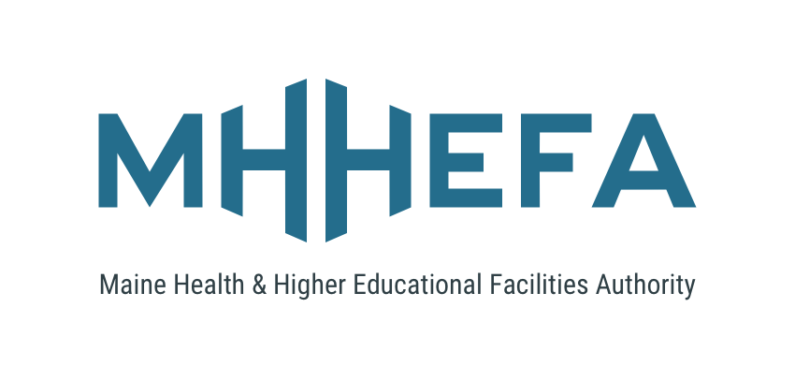

**Application for Financing**

**Thank you for choosing**

**Maine Health and Higher Educational Facilities Authority (MHHEFA)**

**Your First Stop for Bond Financing**

**HEFAProgramOfficer@mmbb.com**

**207.622.1958**

**www.mhhefa.com**

**MHHEFA**

**127 Community Drive**

**Augusta, Maine 04330**

**General Instructions**

**Section A: Project Summary\Executive Summary:**

A project summary should be submitted to the Program Officer prior to the submission of a full application (maximum of one page). The summary should provide details of the project being financed (or refinanced) including property, dollar amounts, schedule, construction agreements and impact to organizational mission. This summary allows the MHHEFA team to quickly address any questions or concerns that could impact eligibility or deal execution.

The reviewed, revised Project Summary can be used as the basis of the Executive Summary component of this application. While this is the recommended process the Authority will accept applications submitted without the benefit of this review if they are in good order.

**Section B: Borrower Profile:**

If you have an updated borrower profile on file, then you can include that and skip to section C. If not, then please provide all requested information.

**Sections C & D: (to be completed by all borrowers)**

**Sections E: Operational Data**

If you have the requested data in an existing digital format (i.e spreadsheet) you may submit it as an attachment. All attached files must be in PDF format and in portrait orientation.

**Applicant Certification**

A signed certification must be included with the application.

**Document List:**

Assemble all documents into a single PDF and submit to the Program Officer for review. Applicants should submit two PDF files only - one completed application with signed certification and the second a complete document list that also includes the application as the first document. All documents should be formatted to be portrait orientation.

* 501(c)3 Determination Letter
* audited financial statements for the last three fiscal years
* operating budget for the current fiscal year;
* most recent internal financial statements;
* Pro-forma financial statements for the next two years, or if a new project, for the first two years after completion of the project;
* Sources of revenues for patient services (healthcare)
* Utilization statistics
* Sources and uses of funds (if not included in application section D)
* Board Resolution approving this financing request (if necessary)
* Certificate of Need and/or DHS Determination Letter (if applicable, healthcare only)